Milestone 2 Delivery Summary

Link to google drive: <https://drive.google.com/drive/folders/1iwpRBO10wl05VzcExPnfZQ7xo_b9Qiau?usp=sharing>

# Submission Files

## Overall Performance

|  |  |
| --- | --- |
| File Name | Caption |
| [Robot demo motor working.mp4](https://drive.google.com/open?id=1sa3gdZFc-xCA5cI1TzytoEpZRWJ5iwoR) | Completed test run before Milestone 1 |
| [Quick snapshot of beginning of milestone1.mp4](https://drive.google.com/open?id=1sYwxrqCv60UlbV5_0llzAa4xkls5cSYj) | Setup during Milestone 1 |
| [Milestone 1 Videos](https://drive.google.com/open?id=1HQz6jVDMT7tqM27iEY2V0v4xCvzLkdot) | Folder with three videos detailing each trial of Milestone 1 |

## Mechanical

|  |  |
| --- | --- |
| File Name | Caption |
| [Storing and Transporting](https://drive.google.com/open?id=14nPLlAg639OejTN1-Fr9fZ6zmcrmY3HV) | Two photos indicating how the finished product is stored in LFF and transported via UberWAV van |
| **In folder “**[**Mechanical Design**](https://drive.google.com/open?id=1WhRNnLV9hEP6_GbVLdPR5SqH1iBfmTS_)**”** | |
| [Gripper Design V1.0.jpg](https://drive.google.com/open?id=1sIUHZfJxm7e_Yf3ncHz1kDa12LqNBC2h) | A photo of a prototype carved out of a particle board to allow the charging plug to fit through snuggly. |
| [Gripper Design V2.0.step](https://drive.google.com/open?id=1ZWeDo6gfhPKHOebLGO-F4KZqiVkfDSpx) | Step file for the second iteration of gripper design, which is 3D printed and used for Milestone 1 and the final mechanical build. |
| [Gripper Design V3.0.step](https://drive.google.com/open?id=1uqXpu2mRAnkkMeS5iESqcA-EyIqOSgdb) | Step file for the third iteration of gripper design, which is intended to be 3D printed and used for future milestones. |
| [Mechanical Design V1.0.step](https://drive.google.com/open?id=1RRLB3SAwkQft9KywCDFdM1gkKHkXE69H) | Step file for intended building specification before Milestone 1 |
| [Mechanical Design V2.0.step](https://drive.google.com/file/d/1TlfWrx5KvtUBSFzFsrqxAOYVVOGI4i_H/view?usp=sharing) | Step file for intended building specification for the final mechanical build and future milestones |
| **In folder “**[**Mechanical Build**](https://drive.google.com/open?id=1I8TDakzyeJuCWZ-H2GqEV-358rHnH0x7)**”** | |
| [Build Process Before Milestone 1](https://drive.google.com/open?id=1JM8wGBICO5z_nCHDTebfWp6SfNGV3_2q) | A folder with photos and videos, titled and listed in chronological order, describing the complete build process of the mechanical system in preparation for milestone 1 |
| [Improvements after Milestone 1](https://drive.google.com/open?id=1_nTnbDoXdXfd0ACDvUFRRZGg9-zXCV89) | A folder with photos and videos, titled and listed in chronological order, describing the steps taken to improve the mechanical system after milestone 1. Namely, the structures holding wheels for guide rails and timing belt pulleys are reinforced and made adjustable, and the position of the stepper motor is adjusted to be lower. |
| [Final Mechanical Build](https://drive.google.com/open?id=1I8TDakzyeJuCWZ-H2GqEV-358rHnH0x7) | A folder with five photos indicating the final mechanical build before LFF is closed down. The build differs from the intended design, as one guide rail, two wheels, and new 3D printed vertical plate are not yet attached. |

## Electrical

|  |  |
| --- | --- |
| **File Name** | **Caption** |
| [Divergence on sensor choices and camera](https://drive.google.com/open?id=1wNLZLjBLbOh_hc5Hi6WEa3reS_WpFodz0dPDjQGgmqw) | Our divergence process on camera and sensor selection. |
| [Electric diagrams.pdf](https://drive.google.com/open?id=1gv2XMN3f2gcYHcv-oxBMFFO2rRf6H_9B) | Diagram of connection of electrical components, including motors, motor drivers, camera, microcontroller, IMU sensor. |
| [imu.py](https://drive.google.com/open?id=1ODtAMuyu4Mbs_g0U0B7yz3fKUc-9bigX) | Python code for getting IMU sensor input, blank because there wasn’t time to finish it |
| [Microcontroller selection](https://drive.google.com/open?id=15d8fuDdc3Xmsr-HRToQiMWXjWmFn26tFkwsvIdX1_d8) | Spreadsheet for microcontroller divergence and convergence process |
| [Motor calculations for lead screw](https://drive.google.com/open?id=16B70g2Omam1PsrbXxdOreKfeVds7u9QK) | Motor calculation to verify that Nema17 2004S satisfies the torque and rotational speed requirement for controlling the lead screw. |
| [motor selection](https://drive.google.com/open?id=1_AyA0AxGlhD6I3hbEKWg0iyrfSJ0xHOEM6D01Lwlz9Y) | Spreadsheet for the motor divergence and convergence process |
| [motor.py](https://drive.google.com/open?id=1_-Xynr0NEIebLhDjSIrgf_wBVMhmJoCv) | Python functions for controlling the stepper motors, to be imported by main.py in the software folder |
| [Pi instructions](https://drive.google.com/open?id=1j3xD93wpEQeMGN-Jv8mOw-mI1kkXAUFSq4npWuLYxy8) | Instructions written to inform our team how to SSH into raspberry pi when no keyboard or monitor is present to directly program the pi. |
| [tutorial.py](https://drive.google.com/open?id=1pcPQafG8tEpe5t6X3GXVK8fIhc9e1-IX) | Python code from a Youtube stepper motor tutorial video, used as a reference to write motor.py |
| [Motor driver connection](https://drive.google.com/open?id=1NemvBSyCfAW9c5cSLykIGsKvcoHbBuDc) | A picture of the connection between stepper motors, motor drivers, and raspberry pi |
| [Leo testing SSH](https://drive.google.com/open?id=1Qvaft1HF8SPDpVhgAvCVH-C-0XwyoL43) | Leo testing the SSH connection to pi before milestone 1 |
| [Raspberry pi GPIO pins](https://drive.google.com/open?id=1zAipSlpr6LVXzYCEBrH_5mq_la-eC4UC) | The connections from raspberry pi, including 5V, GND, GPIO 5, 6, 20, 21, 2, 3 |
| **In folder “**[**Code for Milestone 1**](https://drive.google.com/open?id=1VJDILNlRjXtxZPj8Xsx-sqFxJAoY1Rsm)**”** | |
| [electrical.py](https://drive.google.com/open?id=1raveBm52eFB2rlj5pOrGOA_l5a7dm3tr) | Python functions for specific motor control |
| [main.py](https://drive.google.com/open?id=1r8RgtEVXU9dqiuHwrjX8CIulfFOtkpNg) | Main program for detecting keyboard input, remotely controlling the robot |
| [keyboard.py](https://drive.google.com/open?id=1P_Mu2W0q8YkpYNYguPV4Svc1ju-jCSWr) | Helper function to detect keyboard input |
| [stepper.py](https://drive.google.com/open?id=1VZdQC1mTK6MFoJtMB2B3Occx35CqIpE5) | Sample code to control stepper motors from online sources |

## Software

|  |  |
| --- | --- |
| File Name | Caption |
| [main.py](https://drive.google.com/open?id=1YuNbNHdRvZvCAXOal0O9Zo9sdqnpI8e8) | The main program for milestone 2. It makes use of functions from imu.py and motor.py, and combines with computer vision methods. |
| [pose.py](https://drive.google.com/open?id=1MZx1Gyfn7LieFkU_XFl0Kc20laLgsQrJ) | This is for pose estimation, but is not required for milestone 2. It was done weeks before milestone 2, as part of the progress in preparation for milestone 3. |
| [cameracalibration.py](https://drive.google.com/open?id=1f_YZGSp4f7D5_7CbEUBjLibXxBMcCZR3) | This file calibrates the camera with a chessboard pattern, and calculates the camera matrix and the distortion matrix. This is necessary for 3D reconstruction, angle detection, distance detection, etc. |
| [calibration.jpg](https://drive.google.com/open?id=18IyBYZQ0RsC22ayOK9KwUJU1qh7pvsmC) | This shows a picture where all chessboard corners were recognized and are used for calculation of the camera matrix. |
| [pose estimation.avi](https://drive.google.com/open?id=1Vt7xMs0CEUZTz4AQWcOl12eeaENxjwa-) | This shows some basic 3D reconstruction on a chessboard from cameracalibration.py, which can later be processed to find the Euler angles. Note that the axis jumps around, which has been fixed in pose.py. The processing speed is quick enough to give almost instant output for the video. |
| [sample output.png](https://drive.google.com/open?id=1rxvE0OgEEP2fRvb_ARNgIkL9TrSThbyc) | This shows a simple test, which involves printing all commands instead of driving the motor. The numbers are quite close to actual value. |
| [undistorted image.png](https://drive.google.com/open?id=1vPIvxS8G2gBWMnrzFbkzldN69JtbMhj5) | This shows the effect of applying the distortion matrix. A red dot at the centre reminds us of the alignment during testing. |

# Project Management

## Current Design

In terms of the mechanical system, the mechanical design is completed, and the build process is almost complete. We made improvements of the system after Milestone 1, mostly reinforcing the structure, adjusting the height of the moving z-axis to the specified setting, and changing the design of timing belt and guide rails. Currently, the system allows for smooth movement in all axes without additional supporting weight. The tensioning of the timing belt and the tensioning between wheels and guide rails are easily adjustable, which allows for the upper structure to be detached from the base plate for easier transport and storage. The current build still differs from the intended design and it lacks an additional guide rail and two guide rail wheels which could provide additional stability. The current build is also missing an updated 3D-printed vertical plate ([Gripper Design V3.0.step](https://drive.google.com/open?id=1uqXpu2mRAnkkMeS5iESqcA-EyIqOSgdb)), which is designed to improve the system’s ability to hold the charger plug firmly during operation.

The electrical and software part of the design has a backbone, but still requires further testing and debugging. We have written all the code for the stepper motor control, computer vision, as well as the main program that incorporates everything together. These allow accurate position control for the x, y, z - axis of movement. By controlling the bottom wheels separately, the rotational degree of freedom is also achievable with high accuracy. The main program has different phases for detecting the charging port location. First, it takes a picture and tries to locate our visual signal -- the chessboard. Next, it controls the stepper motor to drive the belt, so that the camera is aligned with the chessboard. It then moves the charger horizontally a certain distance, as the chessboard will be located some horizontal distance away from the actual charging port location. Once it confirms that the location of the charging port is correct (done by taking a picture and comparing it to another picture that was taken beforehand), the insertion action is performed, which drives the two wheels forward simultaneously.

Overall, our current design is almost complete in terms of mechanical, has some basic electrical components working, and many testing and calibration to be done in the software aspect. It should be able to perform an autonomous insertion of the charger given a correct angle and the height of the charging port. What needs to be improved is mainly calibration to fulfill the requirements of milestone 2. These calibrations include the specific accelerations, rotation to distance measures of the motor, as well as the camera specifications and reference images to be taken. Unfortunately, due to the sudden closure of U of T and Myhal LFF, we are unable to perform any further testing and calibration.

## Contributions

**Richard**

* Mainly responsible for the mechanical design and construction
* Selected overall design of movement as a Cartesian robot with a rover base
* Selected materials and methods for frame, linear motion, and guide rails
* Helped with the assembly of electrical circuit
* Helped with writing python code for motor control
* Responsible for purchasing materials and bookkeeping

**Leo**

* Mainly responsible for the electrical section
* SSH raspberry pi
* Selection of stepper motors, motor drivers
* Design main electric circuit
* Help the mechanical assembly of robot base
* Written python code for motor control
* Partly responsible for the power selection mechanism

**Manqiu**

* Software design, including the main program
* Learning and applying computer vision using the OpenCV library
* Selection of camera and distance sensors
* Helped with mechanical build
* Partly responsible for the power selection mechanism

## Snapshot of Trello

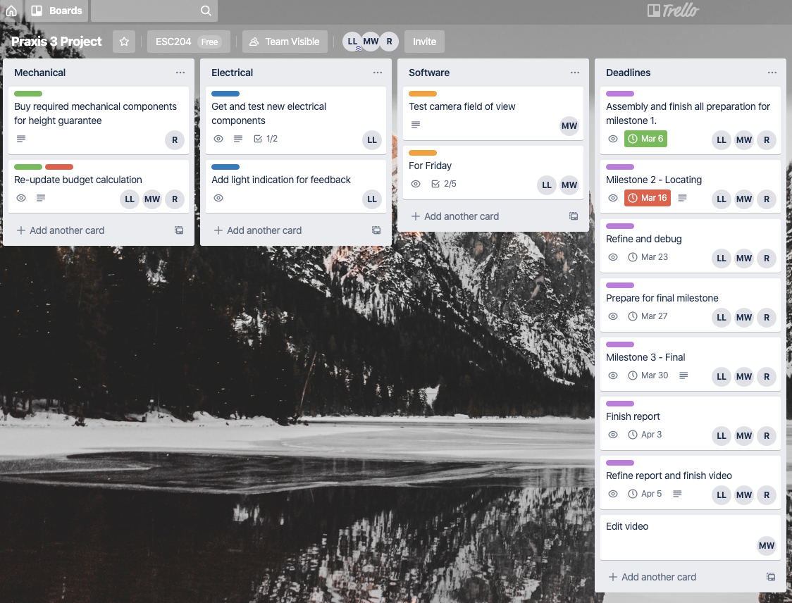

An overview of the organization part 1.

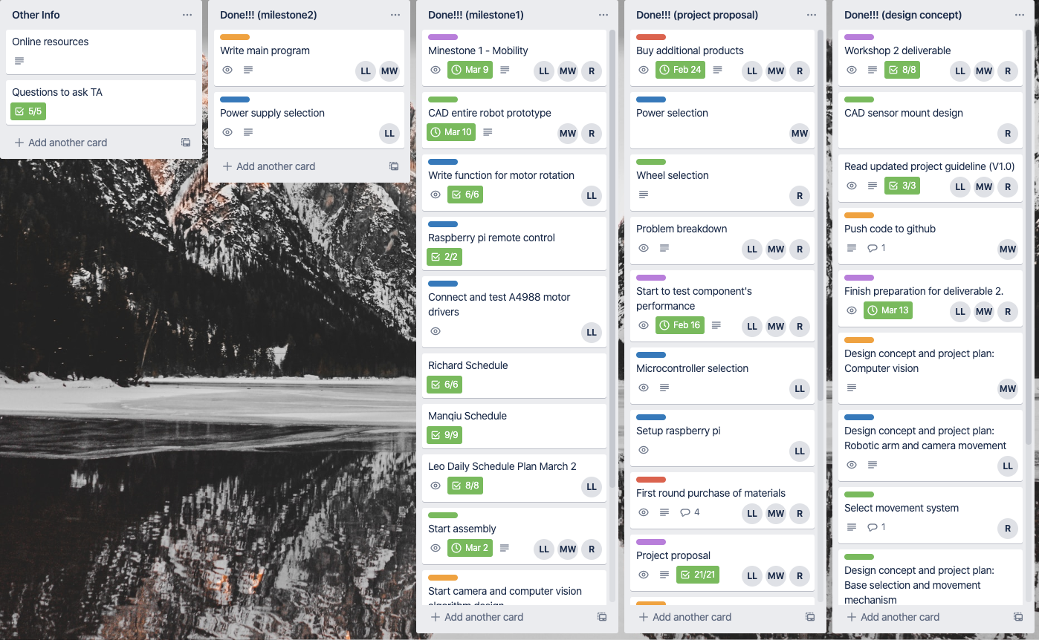

An overview of the organization part 2.

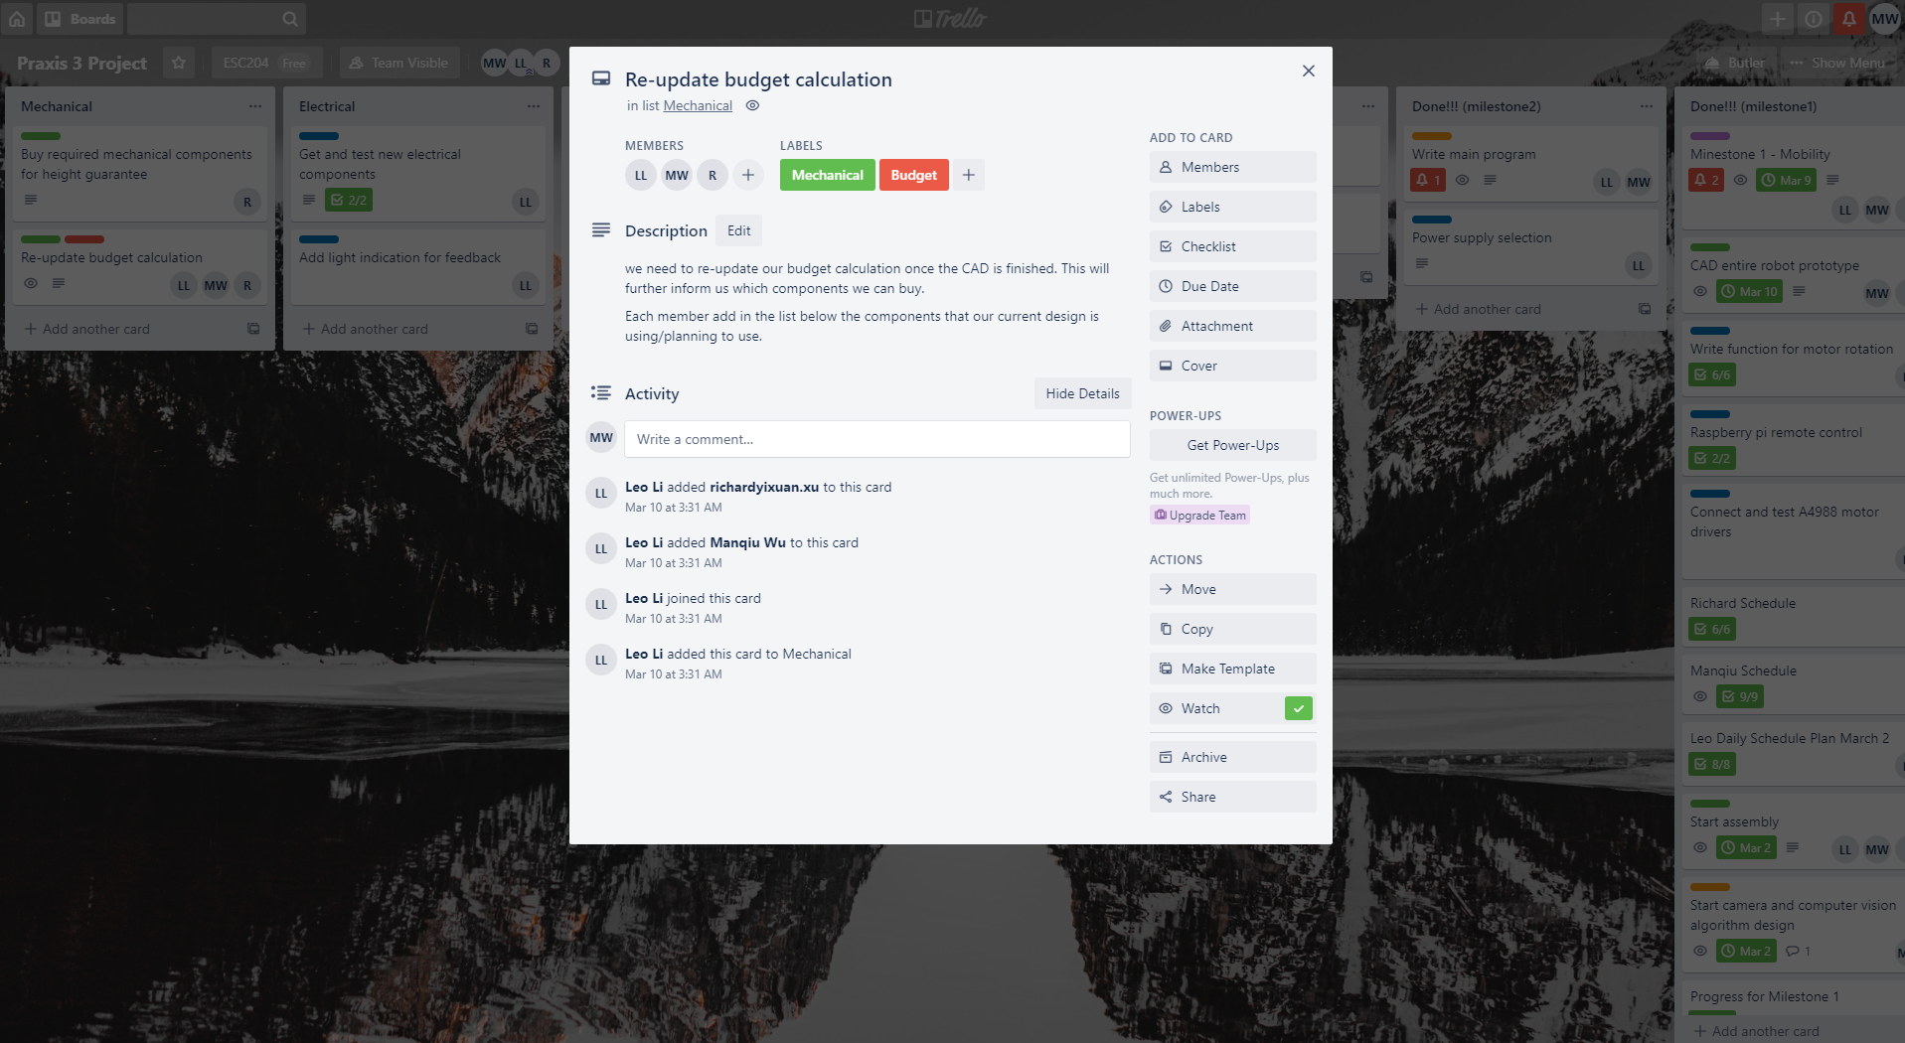

An example of detailed task assignment.